**System frequency inverter provides a complete solution for medium voltage applications**

***The MVW3000 medium voltage variable speed drive, which features extremely high efficiency, power density and reliability, is sold as a complete system integrated into a switchgear cabinet.***

WEG, a leading global manufacturer of drive technology, presents the new MVW3000 series of variable speed drives for voltages from 2.3 kV to 8 kV and power levels from 280 kW to 2,400 kW. This device family is built with multilevel technology and cascaded H bridges (CHB). The multilevel topology is based on the series connection of three to ten low voltage (690 V) power modules with IGBT output inverters in H-bridge configuration, depending on the output voltage. That makes it possible to achieve voltage levels in the medium voltage range using proven standard low voltage components (diodes, IGBTs and plastic film capacitors) in a cost-effective manner. As a special feature, the MVW3000 is supplied as a complete system integrated into a switchgear cabinet, including medium voltage isolator, fuses, multilevel feed transformer and frequency inverter.

“The present voltage and power range is only the first stage in the product evolution. Higher voltages and power levels are already available upon request”, says Johannes Schwenger, Head of Product Management Low Voltage and Medium Voltage Drive Systems Europe at WEG. “The MVW3000 is a high-performance all-in-one solution which eliminates the need for additional medium voltage switchgear. This variable speed drive system features outstanding input and output parameters, energy efficiency and high availability, along with easy maintenance, modularity, and gentle motor handling. That makes this variable speed drive system the ideal complement for all commercially available medium voltage motors and the perfect choice for retrofit projects thanks to its virtually sinusoidal inverter output voltage.”

The MVW3000 variable speed drive system provides extremely high drive performance. The mains power factor is above 0.95 over the entire motor speed range, without any additional harmonic filter or compensation capacitors. The integrated device architecture delivers outstanding mains harmonic distortion figures for current and voltage (THD I/V and TDD) in accordance with IEEE 519, IEC 61800-3 and G5/4-1. The device complies with the limits stated in these standards even in its basic configuration.

The inverter efficiency, including the transformer, exceeds 95% over the entire motor speed range and is more than 96% with load levels above 40%. The charging circuit for the multilevel power transformer ensures transformer core magnetisation without inrush currents and gentle charging of the DC link capacitors for the inverter stage.

The power transformer enables adaptation of the mains voltage to the motor output voltage and reduction of the common-mode voltage on the motor winding. It also reduces common-mode currents through the motor bearings in order to maximise bearing life. The interfaces between the frequency inverter CPU and the power stage for IGBT control, temperature monitoring, voltage feedback and current feedback are implemented using fibre optics to increase noise immunity and provide effective isolation between the control and power sections. The power stages (H bridges) are built with plastic film capacitors, semiconductor fuses and an automatic inverter bypass function to provide higher system availability in the event of a fault. The virtually sinusoidal output voltage and current reduce power dissipation, vibrations and torque pulsation in the motor.

In the interest of enhanced reliability and system availability, the MVW3000 is equipped with motor protection devices for protection against overload, overheating and motor rotor blockage. The temperatures of the power stage and transformer are also constantly monitored.

As a package system, the MVW3000 simplifies installation and commissioning. The plug-in power stages facilitate easy maintenance and fast replacement. With dimensions of 3,900 x 2,210 x 1,100 mm (W x H x D), the variable speed drive system also has a small footprint. Furthermore, it can optionally be equipped with all commonly used industrial communication protocols, including Modbus, Profibus, Devicenet and Ethernet.

Follow WEG on  Description: Description: Description: Description: Description: Description: Description: Description: Description: Description: Description: Description: Description: Description: Description: Description: Description: Description: Description: Description: Description: Description: Description: Description: Description: Description: Description: Description: Description: Description: Description: Description: Description: Description: Description: Description: Description: Description: Description: Description: Description: Description: Description: Description: Description: Description: Description: Description: Description: cid:image009.jpg@01CE8155.D3CFD760   Description: Description: Description: Description: Description: Description: Description: Description: Description: Description: Description: Description: Description: Description: Description: Description: Description: Description: Description: Description: Description: Description: Description: Description: Description: Description: Description: Description: Description: Description: Description: Description: Description: Description: Description: Description: Description: Description: Description: Description: Description: Description: Description: Description: Description: Description: Description: Description: Description: cid:image011.jpg@01CE8155.D3CFD760  Description: Description: Description: Description: Description: Description: Description: Description: Description: Description: Description: Description: Description: Description: Description: Description: Description: Description: Description: Description: Description: Description: Description: Description: Description: Description: Description: Description: Description: Description: Description: Description: Description: Description: Description: Description: Description: Description: Description: Description: Description: Description: Description: Description: Description: Description: Description: Description: Description: cid:image010.jpg@01CE8155.D3CFD760

**Figure captions:**

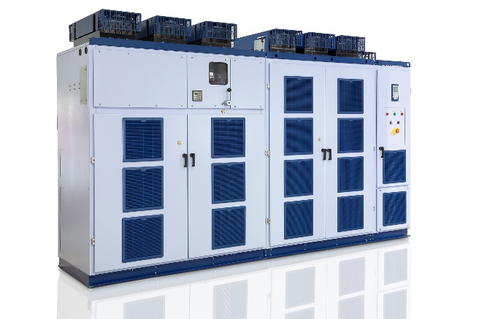

**WEG000851_Figure1:** The MVW3000 medium voltage variable speed drive is designed as a package solution for fast, easy installation and commissioning

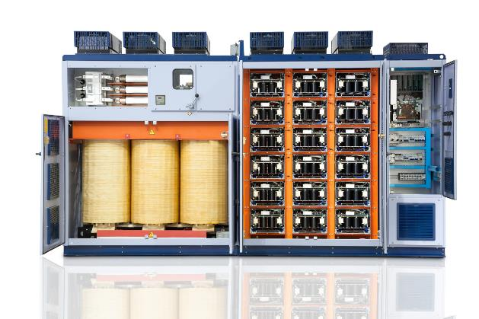

**WEG000851_Figure2:** The MVW3000 is supplied as a complete system integrated into a switchgear cabinet, including medium voltage isolator, fuses, multilevel feed transformer and frequency converter

## About WEG

WEG is one of the largest global manufacturers of electric equipment, having five main Business Units: Motors, Energy, Transmission and Distribution, Automation and Coatings.  The company employs over 30,000 people worldwide and in 2015 achieved global sales of US$ 3.34 billion, representing success across a wide range of product groups.  These include the latest generation of transformers, LV control gear, generators, gear motors, inverter drive systems, soft starters, LV/MV and HV motors, ATEX-compliant explosion proof motors, smoke extraction motors and full turnkey systems.

Its power generation, transmission and distribution solutions enable those across many industries, especially in the oil & gas, water, power distribution, chemical and petrochemical markets, to operate more efficiently, and to reduce energy usage, carbon emissions and environmental impact. In addition, WEG provides full solutions for renewable energy projects, producing complete wind turbine and solar energy systems.

**Editorial Contact**

Marco Giudici, Technical Publicity  
Tel: +44 (0)1582 390991   
Email: [mgiudici@technical-group.com](mailto:mgiudici@technical-group.com)

**Company Contact**

Marek Lukaszczyk, WEG (UK) Ltd   
Tel: +44(0)1527 513800 Fax: +44(0)1527 513810  
Email: [wuk-enquiry@weg.net](mailto:wuk-enquiry@weg.net)

Web: [www.weg.net](http://www.weg.net)/uk