**WEG presents new SSW900 soft starter series**

***The high-performance soft starters provide gentle starting and stopping of three-phase induction motors along with comprehensive motor protection.***

WEG, a leading global manufacturer of drive technology, presented the new SSW900 series of soft starters at this year’s edition of SPS IPC Drives in Nuremberg (Germany). These compact soft starters, which replace the current SSW06 soft starter series, are designed for industrial and commercial applications. As high-performance top-end devices with integrated PLC functionality, they provide fully programmable algorithms for regulating induction motors as well as fully flexible torque control. The new series covers output currents from 10 A to 412 A in the wide voltage range of 220 to 575 V AC (three-phase) with four case sizes. Thanks to soft starting and integrated protection functions, the SSW900 ensures energy-efficient and reliable operation of electric motors. The device is suitable for a broad range of applications, including blowers and ventilation fans, axial, radial and centrifugal pumps, metering pumps, stirrers and mixers, conveyor belts, extruders, dryers and industrial ovens, turntables, and ball or hammer mills.

Johannes Schwenger, Head of Product Management Low Voltage and Medium Voltage Drive Systems Europe at WEG, comments: “The SSW900 series of soft starters expands our portfolio in an area which was previously not a focus of our activities in Europe. The new SSW900 devices are easy to use, and the integrated PLC allows the output torque to be adapted to the load and the start-up current to be kept as low as possible. Numerous protection functions are also integrated to ensure reliable operation of electric motors.”

The soft starter supports direct motor connection in wye or delta configuration, as well as wye/delta switching with six motor leads. This allows the three motor phases to be wired directly to the three thyristor pairs of the SSW900. As a result, the soft starter only has to provide 58% of the rated motor current (corresponding to the phase current), allowing a smaller device to be used for the same power level. The device has an integrated bypass contactor for longer service life, optimal space utilisation and lower heat dissipation (nearly zero) in the switchgear cabinet. Ease of use is further enhanced by a real-time clock as well as diagnostic and status query functions. Three different stop methods and a kick-start function expand the scope of potential applications.

The LCD display and a new user interface simplify operation and make programming changes quick and easy for users. Commissioning and programming are assisted by wizard functions. USB functionality integrated in the user interface enables configuration of the soft start parameters using the free Windows-based WPS software, as well as programming of the internal SoftPLC using the free WLP software.

The user interface language options include English, German, Portuguese and Spanish. Users can choose from Modbus RTU, Profibus DP, DeviceNet, Ethernet/IP, Modbus TCP and Profinet I/O industrial communication protocols for device connectivity.

Follow WEG on  Description: Description: Description: Description: Description: Description: Description: Description: Description: Description: Description: Description: Description: Description: Description: Description: Description: Description: Description: Description: Description: Description: Description: Description: Description: Description: Description: Description: Description: Description: Description: Description: Description: Description: Description: Description: Description: Description: Description: Description: Description: Description: Description: Description: Description: Description: Description: Description: Description: cid:image009.jpg@01CE8155.D3CFD760   Description: Description: Description: Description: Description: Description: Description: Description: Description: Description: Description: Description: Description: Description: Description: Description: Description: Description: Description: Description: Description: Description: Description: Description: Description: Description: Description: Description: Description: Description: Description: Description: Description: Description: Description: Description: Description: Description: Description: Description: Description: Description: Description: Description: Description: Description: Description: Description: Description: cid:image011.jpg@01CE8155.D3CFD760  Description: Description: Description: Description: Description: Description: Description: Description: Description: Description: Description: Description: Description: Description: Description: Description: Description: Description: Description: Description: Description: Description: Description: Description: Description: Description: Description: Description: Description: Description: Description: Description: Description: Description: Description: Description: Description: Description: Description: Description: Description: Description: Description: Description: Description: Description: Description: Description: Description: cid:image010.jpg@01CE8155.D3CFD760

**Figure captions:**

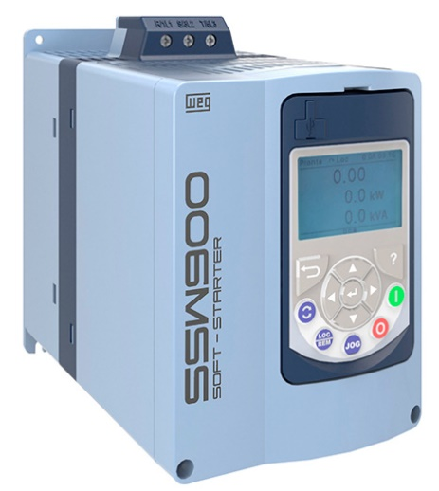

**WEG000853_Figure1:** The SSW900 soft starter features an LCD display and programming wizards for especially convenient operation

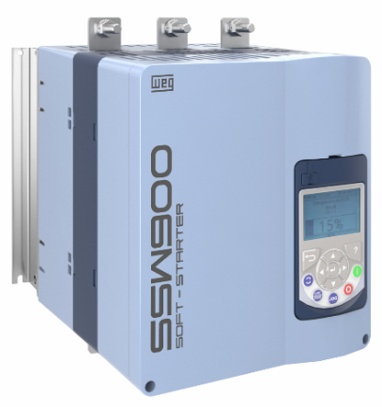

**WEG000853_Figure2:** The high-performance SSW900 soft starter provides gentle starting and stopping of three-phase induction motors along with comprehensive motor protection

## About WEG

WEG is one of the largest global manufacturers of electric equipment, having five main Business Units: Motors, Energy, Transmission and Distribution, Automation and Coatings.  The company employs over 31,000 people worldwide and in 2014 achieved global sales of R$7.8 billion, representing success across a wide range of product groups.  These include the latest generation of transformers, LV control gear, generators, gear motors, inverter drive systems, soft starters, LV/MV and HV motors, ATEX-compliant explosion proof motors, smoke extraction motors and full turnkey systems.

Its power generation, transmission and distribution solutions enable those across many industries, especially in the oil & gas, water, power distribution, chemical and petrochemical markets, to operate more efficiently, and to reduce energy usage, carbon emissions and environmental impact. In addition, WEG provides full solutions for renewable energy projects, producing complete wind turbine systems.

**Editorial Contact**

Marco Giudici, Technical Publicity  
Tel: +44 (0)1582 390991   
Email: [mgiudici@technical-group.com](mailto:mgiudici@technical-group.com)

**Company Contact**

Marek Lukaszczyk, WEG (UK) Ltd   
Tel: +44(0)1527 513800 Fax: +44(0)1527 513810  
Email:  [wegsales@wegelectricmotors.co.uk](mailto:sclarke@technical-group.com)

Web: [www.weg.net](http://www.weg.net)/uk