**WEG expands European automation portfolio**

***New medium-voltage variable speed drives, soft starters and compact circuit breakers expand the existing product line at SPS IPC Drives.***

WEG, a leading manufacturer of drive technology, is on track with the expansion of their European automation portfolio. That is clearly evident at this year’s edition of SPS IPC Drives in Nuremberg (Germany) on 22–24 November, with many product innovations on display at Stand 250 in Hall 3. Among other things, WEG is presenting the new SSW900 soft starters, MVW3000 medium-voltage variable speed drives, and fully updated DWB series of compact circuit breakers, now with three new case sizes. On top of that, WEG’s subsidiary Antriebstechnik KATT Hessen (“AKH”) is showing the new K1Wseries of water-cooled motors, which are especially compact, rugged and cost-effective.

“Our SSW900 soft starter and the MVW3000 variable speed drive system give us access to new target groups in Europe. The first expands our portfolio in an area where we were previously not especially active in Europe, and the second opens the door to medium-voltage applications, which are Europe-wide in high demand”, says Johannes Schwenger, Head of Product Management Low and Medium Voltage Drive Systems Europe at WEG. “Every year we are getting closer to our goal of being a global solution provider for drive technology in Europe, including a full-spectrum automation portfolio.”

The compact SSW900 soft starters, which will replace the existing SSW07 starter series, are designed for industrial and commercial use and cover the output current range of 10 A to 412 A in the international voltage range of 220–575 V 3-phase AC. As high-performance top-end devices with integrated PLC, they provide fully programmable algorithms for regulating induction motors as well as fully flexible torque control. The soft starters feature an integrated bypass contactor for longer service life, optimal space utilisation and lower heat dissipation in the switchgear cabinet. The new user interface simplifies operation and enables users to make programming adjustments quickly and easily. The SSW900 devices are suitable for a broad range of applications, including fans and exhausters, axial flow and centrifugal pumps, process dosing pumps, stirrers and mixers, conveyor belts, extruders, dryers and industrial furnaces, roller tables, and ball or hammer mills.

At SPS IPC Drives, WEG is additionally presenting their new MVW3000 series of variable speed drives with rated voltage from 2.3 kV to 8 kV and rated power from 280 kW to 2,400 kW – and with room for future expansion. Higher voltages and power levels are already possible upon request. This equipment series is built with multilevel technology and cascaded H bridges (CHB). The multilevel topology is based on the series connection of three to ten IGBT low-voltage (690 V) power modules, depending on the desired output voltage. That makes it possible to achieve voltage levels in the medium-voltage range using proven standard low-voltage components (diodes, IGBTs and plastic film capacitors) in a cost-effective manner. As a special feature, the MVW3000 is supplied as a complete system integrated into a switchgear cabinet, including medium-voltage disconnect switch, fuses, multilevel feed transformer and variable speed drive module.

Furthermore, WEG is expanding its DWB series of compact circuit breakers (MCCB) with three additional case sizes for output currents from 800 A to 1,600 A, enabling this product family to cover the current range from 16 A to 1,600 A over six case sizes. As part of the expansion, the entire series now has a new case design with an extensive selection of common accessories, as well as indelible laser marking for industrial deployment. The compact circuit breakers in the DWB series provide flexible, cost-effective and reliable protection for power distribution systems as well as for motors and generators in commercial and industrial applications, particularly in the area of panel building.

With their new K1W series of motors, AKH meets the demand for high-performance motors with a small footprint in various mechanical engineering sectors. Numerous options are available for the motors in the new series, making them suitable for virtually every application. They are used where an optimal performance to package size ratio is required, motor heat cannot be dissipated directly, ambient temperatures are much higher than usual, or noise reduction is required. The water-cooled motors cover the power range from 45 to 710 kW with frame sizes from IEC 200 to IEC 355. They are suitable for mains operation as well as variable speed drive.

**WEG at SPS IPC Drives 2016: Hall 3, Stand 250**

Follow WEG on  Description: Description: Description: Description: Description: Description: Description: Description: Description: Description: Description: Description: Description: Description: Description: Description: Description: Description: Description: Description: Description: Description: Description: Description: Description: Description: Description: Description: Description: Description: Description: Description: Description: Description: Description: Description: Description: Description: Description: Description: Description: Description: Description: Description: Description: Description: Description: Description: Description: cid:image009.jpg@01CE8155.D3CFD760   Description: Description: Description: Description: Description: Description: Description: Description: Description: Description: Description: Description: Description: Description: Description: Description: Description: Description: Description: Description: Description: Description: Description: Description: Description: Description: Description: Description: Description: Description: Description: Description: Description: Description: Description: Description: Description: Description: Description: Description: Description: Description: Description: Description: Description: Description: Description: Description: Description: cid:image011.jpg@01CE8155.D3CFD760  Description: Description: Description: Description: Description: Description: Description: Description: Description: Description: Description: Description: Description: Description: Description: Description: Description: Description: Description: Description: Description: Description: Description: Description: Description: Description: Description: Description: Description: Description: Description: Description: Description: Description: Description: Description: Description: Description: Description: Description: Description: Description: Description: Description: Description: Description: Description: Description: Description: cid:image010.jpg@01CE8155.D3CFD760

**Figure captions:**

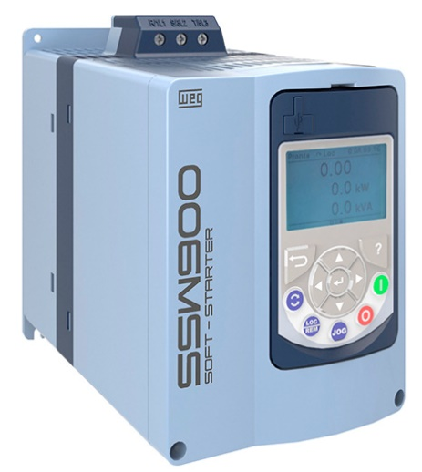

**WEG000850_figure1:** The high-performance SSW900 soft starter provides gentle starting and stopping of three-phase induction motors along with comprehensive motor protection

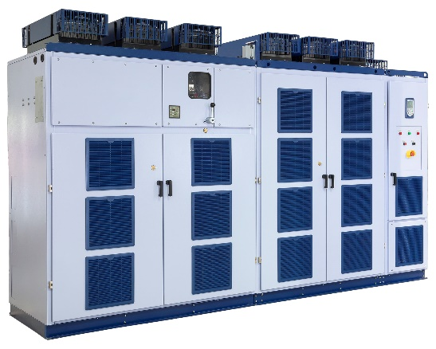

**WEG000850_figure2:** The MVW3000 medium voltage variable speed drive is designed as a package solution for fast, easy installation and commissioning

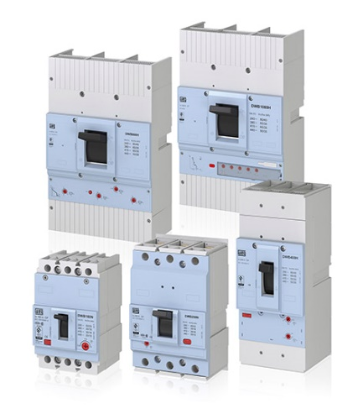

**WEG000850_figure3:** The compact circuit breakers in the DWB series feature a new design

## About WEG

WEG is one of the largest global manufacturers of electric equipment, having five main Business Units: Motors, Energy, Transmission and Distribution, Automation and Coatings.  The company employs over 30,000 people worldwide and in 2015 achieved global sales of US$ 3.34 billion, representing success across a wide range of product groups.  These include the latest generation of transformers, LV control gear, generators, gear motors, inverter drive systems, soft starters, LV/MV and HV motors, ATEX-compliant explosion proof motors, smoke extraction motors and full turnkey systems.

Its power generation, transmission and distribution solutions enable those across many industries, especially in the oil & gas, water, power distribution, chemical and petrochemical markets, to operate more efficiently, and to reduce energy usage, carbon emissions and environmental impact. In addition, WEG provides full solutions for renewable energy projects, producing complete wind turbine and solar energy systems.

**Editorial Contact**

Marco Giudici, Technical Publicity  
Tel: +44 (0)1582 390991   
Email: [mgiudici@technical-group.com](mailto:mgiudici@technical-group.com)

**Company Contact**

Marek Lukaszczyk, WEG (UK) Ltd   
Tel: +44(0)1527 513800 Fax: +44(0)1527 513810  
Email: [wuk-enquiry@weg.net](mailto:wuk-enquiry@weg.net)

Web: [www.weg.net](http://www.weg.net)/uk