Project win: Pump specialist Wepuko opts for WEG motors
WEG to supply six custom-made squirrel-cage motors for driving plunger pumps on offshore oil production ships in Brazil.

Wepuko PAHNKE GmbH (Wepuko), a specialist in high-pressure pumps and compressors which is headquartered in Metzingen, Germany, relies on drive solutions from WEG. Electric motor manufacturer WEG is supplying a total of six squirrel-cage motors from the Master Line series to drive triple-plunger high-pressure hydraulic pumps. According to Fabio Viviani, Project Manager at WEG Germany, the MGF 560 models for this application are special products rated at 1,203 kW and will drive pumps on the P66 to P71 floating production storage and offloading (FPSO) ships of the Brazilian oil producer Petrobras. The explosion-proof six-pole squirrel-cage motors (type MGF 560 A, rated at 1,230 kW, 13.8 kV, 60 Hz, IP 56 W) operate reliably and securely at all times even under the extreme conditions of offshore oil production in pre-salt deep-sea oil fields. Long-time business partner Wepuko bid directly for this high-profile project with WEG motors. The first two MGF 560 motors are scheduled for delivery to Metzingen later this year, with the remaining four to follow in in 2014.

Offshore applications in the oil and gas sector are generally regarded as one of the most severe application areas for high-power electric motors. Oil production in deep-sea fields off the Brazilian coast is especially demanding because the oil is not only located over 1,000 metres below sea level, but also covered by a salt layer up to 2,000 metres thick. WEG has specifically adapted the MGF 560 motors for use on Petrobras’s P66 to P71 FPSOs operating in that region. The units are explosion-proof for Zone 2 (group IIA, thermal class T3) and designed for an ambient temperature range of -45 to +45°C. The starting current is limited to six times the rated current. Due to the aggressive ambient conditions, the heat exchangers, fasteners and motor fans are made from stainless steel to provide enhanced corrosion resistance. The motor windings are protected against voltage surges by capacitors and integrated surge protectors. The motors are certified by INMETRO for use in explosion hazard areas and by BV Bureau Veritas for shipboard use. The motors operate reliably and with guaranteed efficiency even under extremely harsh conditions.

According to Andreas Schulte Mesum, Director Energy Business at WEG Germany, Petrobras chose the Wepuko solution with WEG motors not just for technical reasons: “We have already executed several projects successfully for Petrobras. As a result, we are very familiar with the customer and the specific requirements of offshore oil production. We specifically adapted our MGF motors for this especially demanding project – you could almost call them ‘handmade’. Another small plus was unquestionably the fact that we could supply the complete documentation in Brazilian Portuguese. We are especially pleased to be able to carry out this exciting project together with an experienced partner like Wepuko.”

The motors in the Master (M) Line were developed in response to the needs of the global oil and gas industry. They provide high performance, reliability and security under the harshest operating conditions on land and in the offshore sector. They also combine many years of experience with a broad application range and all classifications for explosion hazard areas in accordance with the ATEX directive. M-Line motors are used worldwide in a wide variety of applications, including water injection, multi-stage gas compression and oil pipeline operation, and they are WEG’s core product for the oil and gas market. With rated power up to 30 MW, these induction motors are designed for relatively large applications and can be built as squirrel-cage or slip-ring rotors. The housing is made from grey cast iron for frame sizes from 280 to 560, while fully welded housings are used for frame sizes from 630 to 1800. The motors are available with operating voltages from 2.3 kV to 13.8 kV in 50-Hz and 60-Hz versions, with 2, 4, 6, 8, 10 or 12 poles. Standard cooling is provided by an air/air heat exchanger; other cooling types (e.g. air/water heat exchanger) are available as options.

Figure captions:
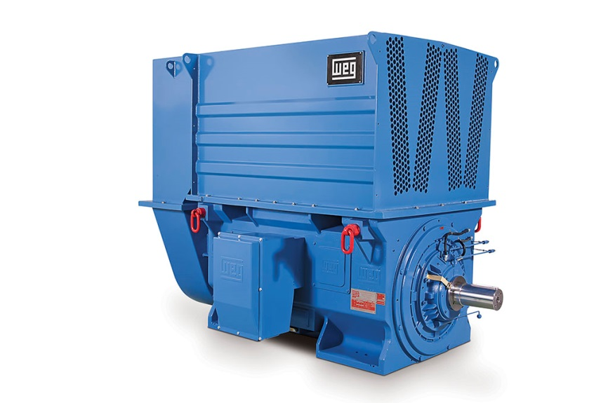
WEG1249_Figure1: M Line squirrel-cage motor from WEG
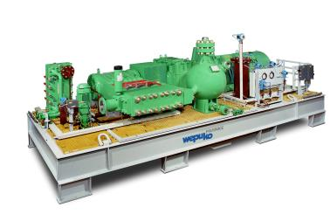
WEG1249_Figure2: Well service pump unit from Wepuko PAHNKE

About WEG
A global major in the power distribution, automation and control sectors, WEG has just celebrated its 50th birthday. The company’s global sales now exceed the US$3-billion mark, representing increasing global success across a wide range of product groups, including the latest generation of transformers, LV control gear, generators, gear motors, inverter drive systems, soft starters, LV and HV motors, ATEX- compliant explosion proof motors, smoke extraction motors and full turnkey systems. In addition, WEG has recently made a significant strategic expansion of its product portfolio, following the establishment of a joint venture for the manufacturing of wind turbines and the purchase of an Austrian gearbox manufacturer, WATT Drive.

About Wepuko
Wepuko PAHNKE GmbH was founded in 1932 and is now a market leader in high-pressure pump technology, with a constantly increasing number of employees in recent years. The fact that Wepuko can grow even under difficult conditions testifies to the quality of their products, service and employees. Customers in diverse sectors, including the petroleum industry, the gas industry, the electricity industry and the food industry, appreciate the high quality standard of Wepuko’s products, which include triple-plunger pumps in various sizes. In addition, Wepuko engineers and delivers complete hydraulic units and systems according to individual specifications, including supervision of installation and commissioning.

Editor Contact
Sarah Claridge, Technical Publicity
Tel: +44 (0)1582 390980 Mob: +44 (0)7872 462646
Email: sclaridge@technical-group.com

Company Contact
Marek Lukaszczyk, WEG Electric Motors (UK) Ltd
Tel: +44(0)1527 513800 Fax: +44(0)1527 513810
Web: www.weg.net
Email: wegsales@wegelectricmotors.co.uk

Web: www.weg.net, www.wattdrive.com

