WEG expands and modernises Watt Drive machinery in Markt Piesting, Austria
New 4-axis machining centre increases production speed and increases the efficiency of geared motor production due to its larger tool magazine
WEG, a leading global manufacturer of motors and drive technology with over 30 production sites around the world, has recently competed a major investment in the modernisation of machinery at its subsidiary Watt Drive Antriebstechnik GmbH in Markt Piesting, Austria. In an initial step, the Austrian gearbox specialist has taken delivery of a new 1.1 million Euro production machine. Installation took place in early August 2018 in spectacular fashion (video) with the use of the world's most powerful all-terrain crane, the Demag AC 1000-9, which has a carrying capacity of 1,200 tonnes.
Purpose: To increase production capacities at the site
The new 4-axis machining centre Makino A99E will be utilised for the machining of gearbox housings and is the first step in a broad-based modernisation/ expansion campaign at the Markt Piesting site. The overall objective is to effectively increase its production capacities. The new production machine will be connected to the existing, already modernised multi-level system (MLS) from Fastems and the high-bay warehouse. This will enable the unrestricted continued use of both the high productivity and flexibility of the Fastems system. The benefits mount up - the new production machine will also be able to reduce machining times by some 25% and the significantly larger tool magazine provides greater tool variety. These tools can be used to machine both the gearbox housings of the proven MAS geared motor series and the newly developed WG20 geared motor range, which is currently being expanded for rated torques of up to 18,000 Nm.
Ambitious investment plans through to 2023 makes the site fit for the future
From autumn 2018, the first step will be an extension to enlarge the existing production and storage area by more than 70%. By the year 2023, further investments in the two-figure million Euro range are planned for the machinery at the Watt Drive site.
Gerald Schubert, Plant Manager at Watt Drive Antriebstechnik GmbH stated, "We want to modernise the site in a sustainable way and secure all of the important competitive advantages in the market. The production of geared motors in Markt Piesting has reputation for maximum quality and we want to continue growing in a competitive market. This is why it is important to increase our production capacities which will deliver shorter process times and will reduce production costs, without sacrificing quality. In turn greater production precision and less scrap inevitably leads to lower costs. Also, new, more powerful machines will enable us to minimise maintenance costs. With the planned measures, we want to set an important new direction for the future of Watt Drive in Austria by the year 2023."

Click here for a drone video showing the installation of the new 4-axis machining centre Makino A99E at Watt Drive: https://www.youtube.com/watch?v=EBRJTycQvww

Follow WEG on

Picture captions:
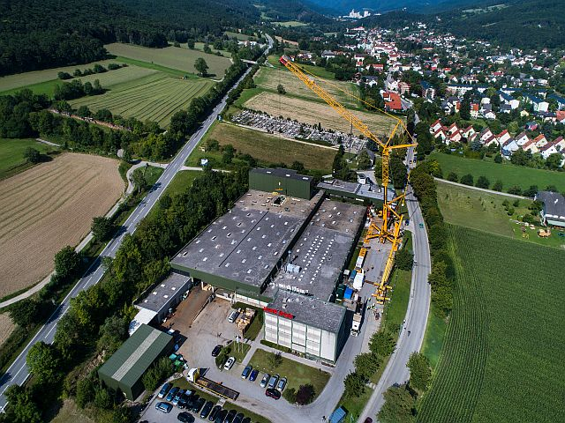

Lead story
Picture: Watt Drive (René Binder), Konrad Kehrer
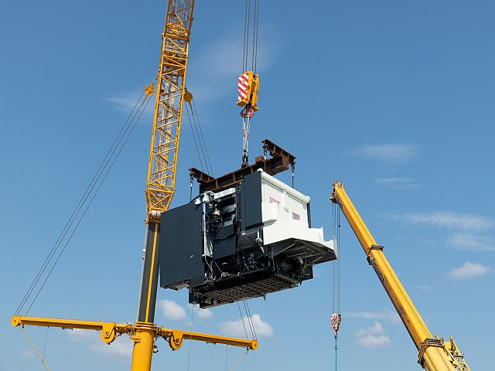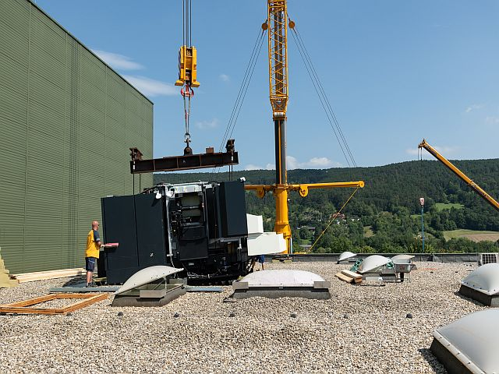
WEG001503_Picture1 + Picture2: Installation of the new Makino A99E machining centre took place in early August 2018 with the world's most powerful all-terrain crane, the Demag AC 1000-9, with a carrying capacity of 1,200 tonnes.
Picture: Watt Drive (René Binder), Konrad Kehrer
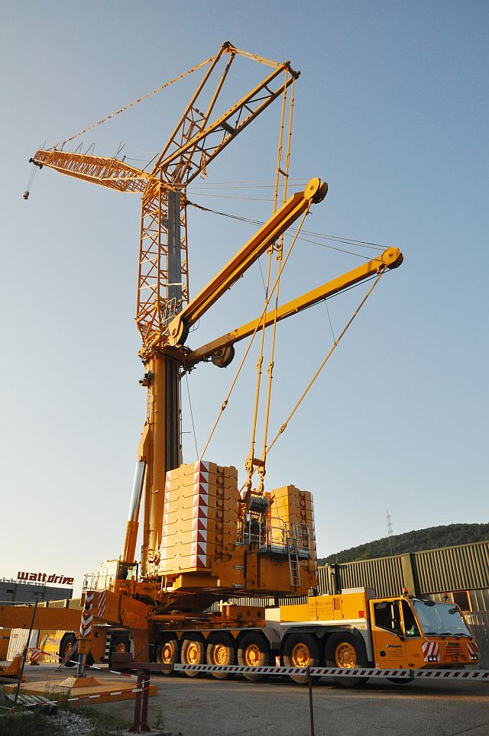
WEG001503_Picture3: The telescopic crane Demag AC 1000-9 used with an auxiliary boom of up to 163 meters of boom length for major construction projects.
Picture: Watt Drive
WEG001503_Picture4 Gerald Schubert, Plant Manager at Watt Drive Antriebstechnik GmbH.
Picture: Watt Drive

About WEG
WEG is one of the largest global manufacturers of electric equipment, having five main Business Units: Motors, Energy, Transmission and Distribution, Automation and Coatings. The company employs over 30,000 people worldwide and in 2017 achieved global sales of R$ 9.5 billion, representing success across a wide range of product groups. These include the latest generation of transformers, LV control gear, generators, gear motors, inverter drive systems, soft starters, LV/MV and HV motors, ATEX-compliant explosion proof motors, smoke extraction motors and full turnkey systems.
Its power generation, transmission and distribution solutions enable those across many industries, especially in the oil & gas, water, power distribution, chemical and petrochemical markets, to operate more efficiently, and to reduce energy usage, carbon emissions and environmental impact. In addition, WEG provides full solutions for renewable energy projects, producing complete wind turbine and solar energy systems.

Editorial Contact
Ian Jarrett, Technical Publicity
Tel: +44 (0)1582 390980
Email: ijarrett@technical-group.com

Company Contact
Marek Lukaszczyk, WEG (UK) Ltd
Tel: +44(0)1527 513800 Fax: +44(0)1527 513810
Email: wegsales@wegelectricmotors.co.uk
Web: www.weg.net

