Single-stage gearboxes from Watt Drive

On applications such as pump drives, gearboxes with high output speed are needed. Single-stage gearboxes from Watt Drive in a power range from 0.12 – 37kW can be delivered in a reduction range of 1 – 11. The type series includes 6 gear sizes with rated torques of up to 1200Nm.

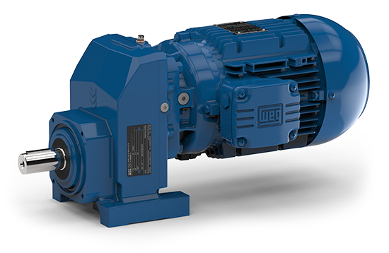
Picture 1: Single stage helical geared motor

The gears are constructed in the UNIBLOCK design, one housing can as well be used in foot or flange design. Additional options like output shafts of stainless steel or shafts in inch sizes top off the product range.

High efficiency through single-stage design:

According to the single-stage gear design, load-depending losses are low. Splashing losses are as well kept down through the appropriate adjustment of the oil filling quantity. For every design, the gearboxes are delivered with the optimal oil filling quantity. According to the application case there are mineral or synthetic lubricants available for the customer. For applications with high operating hours, highly efficient drive systems are realised through a combination with WEG motors.

Gearboxes with NEMA adapters:

For the mounting of NEMA C-Face motors, the single-staged gears can be equipped with the appropriate adapters. 6 adapter sizes can be chosen from NA 56 to NA 284.

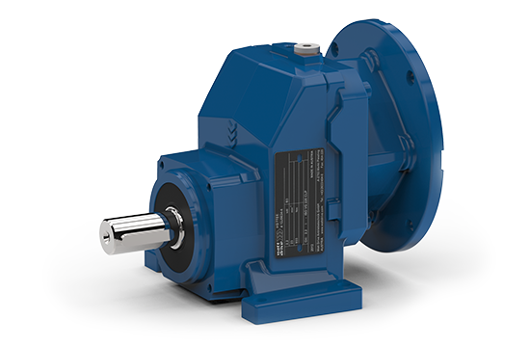
Picture 2: HG 51E NA145

Picture 2 shows a single-stage gear with a Nema adapter. For example, a WEG W22 Motor, size 145T with 1.1kW (1.5HP) can be mounted.

Mountable WEG motors:

Output |  | Rated speed | Frame | Gear unit |  |  |  |  |  | NEMA Adapter
HP | kW | rpm |  | HG41E | HG51E | HU60E | HU70E | HU80E | HG110E
1 | 0.75 | 1750 | 143T | X | X | X | X |  |  | NA143/145
1 | 0.75 | 1750 | 145T | X | X | X | X |  |  | NA143/145
1.5 | 1.1 | 1740 | 145T | X | X | X | X |  |  | NA143/145
2 | 1.5 | 1740 | 145T | X | X | X | X |  |  | NA143/145
3 | 2.2 | 1750 | 182T |  | X | X | X | X |  | NA182/184
3 | 2.2 | 1750 | 184T |  | X | X | X | X |  | NA182/184
5 | 3.7 | 1755 | 213T |  | X | X | X | X |  | NA213/215
5 | 3.7 | 1745 | 184T |  | X | X | X | X |  | NA182/184
7.5 | 5.5 | 1755 | 213T |  | X | X | X | X | X | NA213/215
7.5 | 5.5 | 1755 | 215T |  | X | X | X | X | X | NA213/215
10 | 7.5 | 1750 | 215T |  | X | X | X | X | X | NA213/215
15 | 11 | 1765 | 254T |  |  |  |  | X | X | NA254/256
15 | 11 | 1765 | 256T |  |  |  |  | X | X | NA254/256
20 | 15 | 1760 | 256T |  |  |  |  | X | X | NA254/256
20 | 15 | 1760 | 284T |  |  |  |  | X | X | NA284/286
25 | 18.5 | 1760 | 284T |  |  |  |  | X | X | NA284/286
25 | 18.5 | 1760 | 286T |  |  |  |  | X | X | NA284/286
30 | 22 | 1760 | 286T |  |  |  |  | X | X | NA284/286

WEG Nema Motors:

The ‚High Efficiency'- and ‚Premium Efficiency' three-phase motors of the type series NEMA W22 from WEG labels extremely high efficiency and complies with the efficiency values of the NEMA (National Electrical Manufacturers Association) in the US.

Their power loss is 10% to 40% lower than that of comparable products of other vendors. The NEMA W22 is offered in 2-, 4-, 6- or 8-pole design.

The efficiency of all models exceeds the requirements of the new efficiency classes IE2 High Efficiency and IE3 (Premium). This new contentment is due to the aerodynamically designed housing, that provides for a stronger air stream and better cooling performance. Moreover the terminal box is placed in a fashion that the air can stream along the motor undisturbed. The product is designed with massive motor feet in integrated construction that ensures high rigidity and easy alignment. The reinforced fan cover offers improved protection against impacts.

