**WEG showcases its expertise in electric motors, gear units and systems**

***At the SPS IPC Drives automation trade fair in Nuremberg (Germany), WEG will be presenting geared motors for high torque levels and showcasing a switchgear cabinet system made in Europe.***

At this year’s SPS IPC Drive trade fair, leading global manufacturer of motor and drive technology WEG, is launching their expanded WG20 geared motors portfolio with helical, parallel-shaft and helical bevel gear drives for rated torques up to 5,000 Nm. The housings of the new gear units are manufactured from grey cast iron and are especially sturdy. This makes them ideal for demanding applications within the steel industry plus the heavy-duty industrial sector, amongst others. In combination with high-performance motors available in energy efficiency classes up to IE4, the geared motors provide a lot of power in a compact form.

Also on display at Stand 250 located in Hall 3, are switchgear cabinets manufactured by WEG’s Spanish subsidiary Autrial, which are being showcased in Germany for the first time. From its site in Valencia, the Brazilian drive technology manufacturer supplies the European market with complete industrial switchgear cabinet systems. In addition, WEG is exhibiting one of the industry’s most comprehensive portfolios of energy-efficient electric motors, as well as the current automation products for the European market. This includes variable-speed drives, soft starters and low-voltage switchgear.

“Thanks to the expansion of the WG20 geared motor portfolio, we are now able to handle applications with relatively high torque requirements. In these demanding applications, the robust construction, manufacturing quality and power density of our geared motors are especially beneficial”, says Wilmar Henning, Managing Director of WEG in Germany.

**Energy-efficient geared motors**

A smart pinion concept allows the gear units of the WG20 series to be made in two-stage or three-stage versions over a wide range of gear ratios. This results in very low losses, thus making the gear units very energy efficient. The variant-optimized tooth concept, also makes possible high output speeds and allows for the implementation of a large speed range with all gear unit frame sizes. What’s more, stringent quality standards in the gearwheel production process ensures smooth operation and longer service life of the gear units. The high quality-finish makes the geared motors suitable for even the most demanding applications, and the standard mounting dimensions allow them to be easily integrated into a wide variety of applications worldwide. The WG20 geared motors need very little maintenance and are extremely reliable ensuring machine and system productivity.

**Rounding out the system**

In 2015 WEG acquired the Spanish switchgear cabinet builder Autrial, whose headquarters are in Valencia. At this location 139 employees produce application-specific low-voltage and medium-voltage switchgear cabinet systems for a wide variety of applications, including power generation, renewable energy sources, mechanical engineering and petrochemical. Due to being manufactured in Europe these products can be offered to the market with quicker delivery times, from design to manufacture and commissioning, all within a matter of weeks.

“WEG has been manufacturing complete switchgear cabinet systems in Brazil for a long time. Through the acquisition of Autrial we are now able to do this in Europe, thus offering quicker delivery times. This also allows us to significantly expand our portfolio of automation products and services for the European market plus it strengthens our position in the area of integrated drive solutions”, says Wilmar Henning.

All switchgear systems are manufactured in accordance with the highest quality standards and can be deployed not only in Europe, but also in North America (UL and CSA) and Russia (EAC), as well as explosion hazard areas (ATEX). Autrial gives WEG full control over the entire life cycle of switchgear cabinets, from planning and engineering through production and programming to installation and service. WEG services the entire EMEA region from Spain.

**WEG at SPS IPC Drives 2017: Hall 3, Stand 250**

Follow WEG on  [Description: Description: Description: Description: Description: Description: Description: Description: Description: Description: Description: Description: Description: Description: Description: Description: Description: Description: Description: Description: Description: Description: Description: Description: Description: Description: Description: Description: Description: Description: Description: Description: Description: Description: Description: Description: Description: Description: Description: Description: Description: Description: Description: Description: Description: Description: Description: Description: Description: cid:image009.jpg@01CE8155.D3CFD760](http://www.twitter.com/WEG_Europe)   [Description: Description: Description: Description: Description: Description: Description: Description: Description: Description: Description: Description: Description: Description: Description: Description: Description: Description: Description: Description: Description: Description: Description: Description: Description: Description: Description: Description: Description: Description: Description: Description: Description: Description: Description: Description: Description: Description: Description: Description: Description: Description: Description: Description: Description: Description: Description: Description: Description: cid:image011.jpg@01CE8155.D3CFD760](https://plus.google.com/103642553426782648112)  [Description: Description: Description: Description: Description: Description: Description: Description: Description: Description: Description: Description: Description: Description: Description: Description: Description: Description: Description: Description: Description: Description: Description: Description: Description: Description: Description: Description: Description: Description: Description: Description: Description: Description: Description: Description: Description: Description: Description: Description: Description: Description: Description: Description: Description: Description: Description: Description: Description: cid:image010.jpg@01CE8155.D3CFD760](http://www.linkedin.com/company/weg-europe)

**Figure captions**

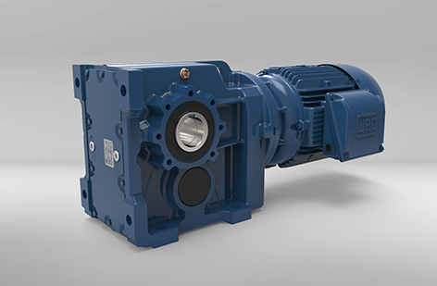

**WEG001198_Figure1:** WEG expands the WG20 geared motor portfolio with spur gear, parallel-shaft and bevel gear units (see image) for rated torques up to 5,000 Nm

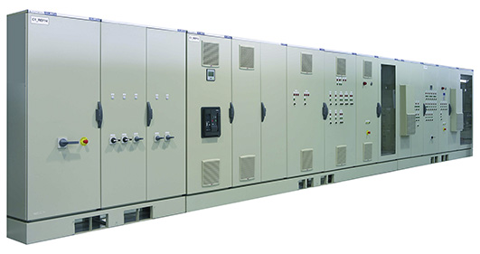

**WEG001198_Figure2:** WEG’s Spanish subsidiary Autrial supplies integrated switchgear cabinet systems for the entire European market

## About WEG

WEG is one of the largest global manufacturers of electric equipment, having five main Business Units: Motors, Energy, Transmission and Distribution, Automation and Coatings.  The company employs over 30,000 people worldwide and in 2016 achieved global sales of US$ 3.2 billion, representing success across a wide range of product groups.  These include the latest generation of transformers, LV control gear, generators, gear motors, inverter drive systems, soft starters, LV/MV and HV motors, ATEX-compliant explosion proof motors, smoke extraction motors and full turnkey systems.

Its power generation, transmission and distribution solutions enable those across many industries, especially in the oil & gas, water, power distribution, chemical and petrochemical markets, to operate more efficiently, and to reduce energy usage, carbon emissions and environmental impact. In addition, WEG provides full solutions for renewable energy projects, producing complete wind turbine and solar energy systems.

**Editorial Contact**

Ian Jarrett, Technical Publicity  
Tel: +44 (0)1582 390980   
Email: [ijarrett@technical-group.com](mailto:ijarrett@technical-group.com)

**Company Contact**

Marek Lukaszczyk, WEG (UK) Ltd   
Tel: +44(0)1527 513800 Fax: +44(0)1527 513810  
Email:  [wegsales@wegelectricmotors.co.uk](mailto:sclarke@technical-group.com)

Web: [www.weg.net](http://www.weg.net)/uk