Updated motor portfolio for general industrial applications
WEG has extensively updated its portfolio of standard industrial motors with the W40, W50 and W60 series. Thanks to the optimised design, the new compact three-phase induction motors deliver reliable high performance even under adverse conditions.
WEG, a leading global supplier of drive technology, recently updated its portfolio of standard industrial motors to incorporate advanced technology, resulting in the W40, W50 and W60 motors series. The motors collectively cover the power range from 11 to 4,250 kW at frequencies of 50 and 60 Hz. The three-phase induction motors are suitable for nearly all industrial applications requiring high performance and reliability, including pumps, compressors and fans. The design has been optimised to make the motors more compact than their predecessors, with lower weight, smaller dimensions and a reduced footprint. With sturdy, innovative grey cast iron housings, they are suitable for use under extremely adverse conditions and assure low noise and vibration levels. Optimised rotor and stator laminations together with improved motor cooling give an especially high power density (ratio of output power to weight), making the standard industrial motors in the W40, W50 and W60 series among the most efficient of their sort on the market.

The two-pole and four-pole motors in the W60 series are available in frame sizes from IEC450 to IEC560, with rated power from 800 to 4,250 kW and rated voltage from 2,300 to 10,000 V. To maximise application flexibility, the motors are available in three configurations: open and self-ventilated (IC01, WP-II), closed and air/air-cooled (IC611, TEAAC) and closed with air/water heat exchanger (IC81, TEWAC). Thanks to their compact design, the motors have a smaller footprint and are the shortest modular motors of their sort on the market. Noise and vibration levels are especially low thanks to sturdy construction with a high-quality grey cast iron frame and shield as well as a true stiff motor shaft that eliminates critical flexural vibrations below the rated speed. This makes the W60 motors a good choice for applications with frequency inverter operation or strong shaking loads. High-quality rotor and stator laminations, high-efficiency fans and optimised heat exchangers enable the motors in the W60 series to achieve above-average efficiency and power density.

The W60 motors are designed for continuous use and are easy to install and commission. They are also ideal for use with medium-voltage frequency inverters as standard motors with no speed restrictions due to critical vibration speeds. The WEG medium-voltage frequency inverters of the MVW0s series are perfect partners. The motors are fitted with roller bearings as standard, but they are optionally available with sleeve bearings. Their modular structure allows users to adapt the motors to their specific applications by adding optional accessories such as differential pressure switches for air cooling, leak detectors for water cooling, an automatic lubrication system for ball bearings, or encoders.

The W50 series is very similar to the W60 series in design and construction, featuring a compact and sturdy grey cast iron frame and high power density. W50 motors with two to twelve poles are available in frame sizes from IEC315 to IEC450, rated power from 75 to 1,250 kW, and rated voltage from 380 to 6,600 V. They also feature low noise and vibration levels (82 dB at 3,600 rpm) and are available with protection ratings from IP55 to IP66. The motors are fitted with ball bearings as standard and are optionally available with sleeve or roller bearings. The W50 motors have IC 411 cooling in accordance with EN 60034-6 and are designed for frequency inverter operation. In particular, the stiff motor shaft eliminates speed restrictions due to critical internal vibrations at motor speeds up to 3,600 rpm in frequency inverter operation. The W50 series is available with mounting options B3, B5, V1 and V6.

The open drip-proofed (ODP) W40 motors with two or four poles are the smallest members of the standard industrial motors family and are only suitable for applications where dirt and moisture are not factors. They are available in frame sizes from IEC160L to IEC450 with rated power from 11 to 1,400 kW for low and medium voltages. They have IP23 or IP24 protection rating. These modular motors also feature especially low noise and vibration levels, with slight differences between the various models (ODP and WPI).

Figure captions:
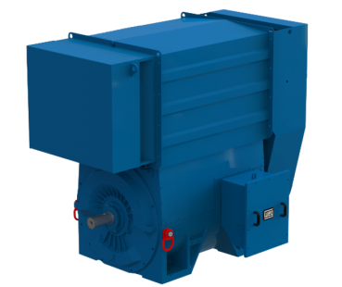
WEG2137_W60: The sturdy, efficient motors in the W60 series are ideal for demanding applications with high motor speed or shaking loads.
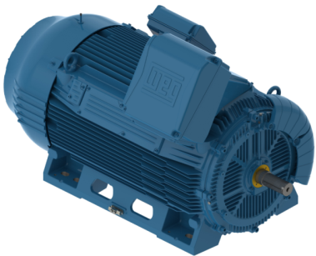
WEG2137_W50: The high performance of the W50 motors makes them ideal for high-speed applications with speeds up to 5,000 rpm, even under adverse conditions.
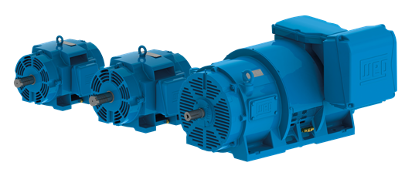
WEG2137_W40: The W40 motors combine extreme compactness with high efficiency and performance for a wide variety of applications, in particular compressors, fans and pumps.

About WEG
WEG is a major global player in the power distribution, automation and control sector. WEG employs 28,000 people worldwide. The company’s global sales now exceed US $3-billion, representing increasing global success across a wide range of product groups. These include the latest generation of transformers, LV control gear, generators, gear motors, inverter drive systems, soft starters, LV/MV and HV motors, ATEX- compliant explosion proof motors, smoke extraction motors and full turnkey systems.

Editorial Contact
Ian Clay, Technical Publicity
Tel: +44 (0)1582 390980 Mob: +44 (0)7768827009
Email: iclay@technical-group.com

Company Contact
Marek Lukaszczyk, WEG Electric Motors (UK) Ltd
Tel: +44(0)1527 513800 Fax: +44(0)1527 513810
Web: www.weg.net
Email: wegsales@wegelectricmotors.co.uk

