WEG introduces IE3-compliant motor switching and protection solutions
WEG, a leading manufacturer of drive technology, has developed IE3-compliant switchgears to ensure excellent reliability when operating IE3 high-efficiency motors, despite higher inrush currents compared to IE2 motors. As a result of using the new switchgear, users can be confident their drive system provides the highest levels of energy efficiency over a long service life, enabling them to reduce the total cost of ownership (TCO) while complying with current environmental regulations.

“Although using premium efficiency motors is now mandatory, the choice of low-voltage switchgear, such as motor protection circuit breakers, is still left to the user. To ensure reliable equipment operation despite higher inrush and starting currents typically found in IE3 motors, users should always consider IE3 compatibility when selecting low-voltage switchgear”, says Zoltan Schaaf, Manager Low Voltage Switchgear at WEG in Germany. “As a leading manufacturer of premium (IE3) and super-premium (IE4) electric motors, WEG has developed extensive expertise in IE3 equipment conformity and all of WEG's current switchgear and protection devices can be used without restriction to ensure the reliable operation of IE3 motors.”

With European Regulation 640/2009/EC coming into force last January, motors with rated power from 7.5 to 375 kW sold in Europe must now achieve at least IE3 energy efficiency levels or IE2 standards if they are equipped with a variable speed drive. To meet this challenge, motor manufacturers have had to rethink their motors’ design, for example, by placing more copper mass in the stator while developing thinner silicon steel laminations in the iron cores, optimising air gaps, larger conductors in rotors and improving cooling systems. These changes make IE3 motors more inductive meaning they usually have lower rated operating currents, higher inrush currents and higher starting currents than IE2 motors. WEG’s comparison tests with IE3 and IE2 motors having the same rated power have demonstrated that - in the lower power range - the starting current of an IE3 motor is about five per cent higher and the peak inrush current about 20 per cent higher.

These tests also demonstrated that WEG’s motor protection relays in the RW series (bimetallic) and new RW_E series (electronic) are not affected by the IE3 motors’ higher starting or inrush currents. Additionally, WEG has upgraded its CWM, CWC and CWB series of contactors to accommodate higher inrush and starting currents, without any adverse effect on the mechanical or electrical service life.

Of all motor protection devices, motor protection circuit breakers are particularly exposed to the higher inrush and starting currents of premium efficiency motors, due to their high sensitivity. With this in mind, WEG has raised the trip level of its MPW series of motor protection circuit breakers from 12 times to 13 times the maximum rated operating current to ensure IE3-compliance. With regard to the further development of energy efficient motors WEG will always provide its customers with motor protection circuit breakers and contactors compliant with the IE standards.

For further information on WEG visit www.weg.net/uk.

Image caption:

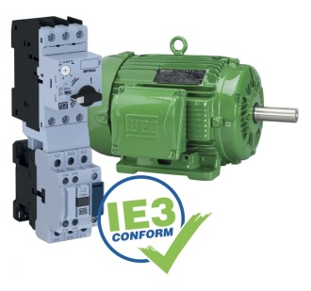
WEG3758_Image1: To ensure reliable equipment operation despite higher inrush and starting currents typically found in IE3 motors, users should always consider IE3 compatibility when selecting low-voltage switchgear

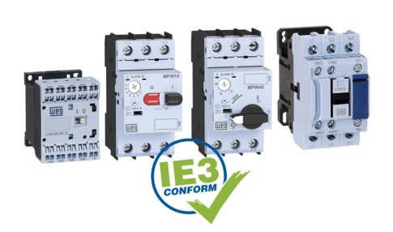
WEG3758_Image2: All of WEG's current switchgear and protection devices can be used without restriction to ensure the reliable operation of IE3 motors

Ends

About WEG
WEG is one of the largest global manufacturers of electric equipment, having five main Business Units: Motors, Energy, Transmission and Distribution, Automation and Coatings. The company employs over 30,000 people worldwide and in 2014 achieved global sales of R$7.8 billion, representing success across a wide range of product groups. These include the latest generation of transformers, LV control gear, generators, gear motors, inverter drive systems, soft starters, LV/MV and HV motors, ATEX-compliant explosion proof motors, smoke extraction motors and full turnkey systems.
Its power generation, transmission and distribution solutions enable those across many industries, especially in the oil & gas, water, power distribution, chemical and petrochemical markets, to operate more efficiently, and to reduce energy usage, carbon emissions and environmental impact. In addition, WEG provides full solutions for renewable energy projects, producing complete wind turbine systems.

Editorial Contact
Marco Giudici, Technical Publicity
Tel: +44 (0)1582 390991
Email: mgiudici@technical-group.com

Company Contact
Marek Lukaszczyk, WEG (UK) Ltd
Tel: +44(0)1527 513800 Fax: +44(0)1527 513810
Email: wegsales@wegelectricmotors.co.uk

Web: www.weg.net/uk

